**GITHUB – PART-1**

1. Create a GitHub account using <https://github.com/>. Use your personal email address and official emails come with restrictions.

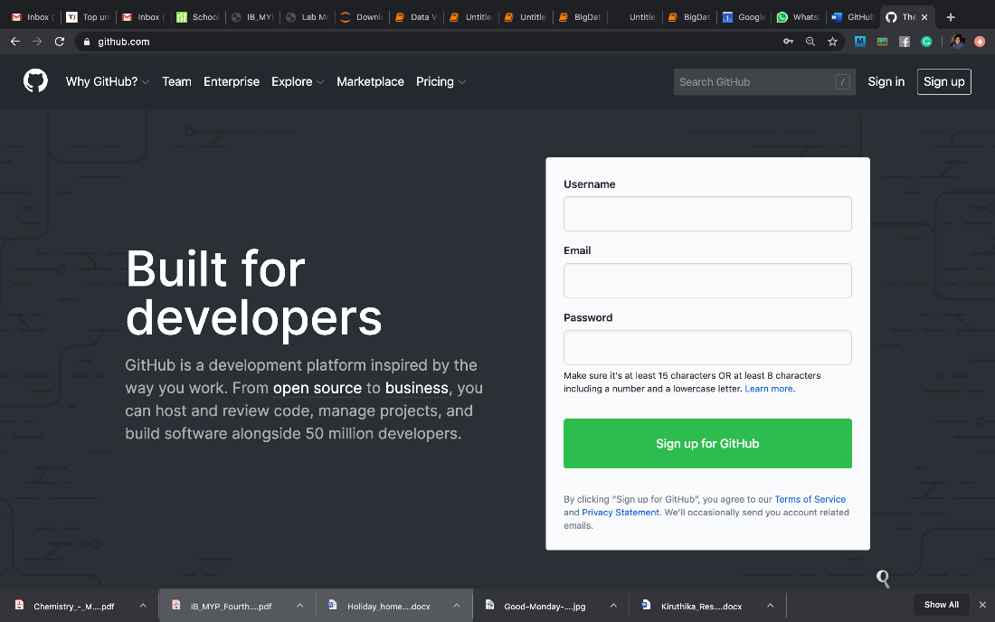

1. Create a new repository (it’s a container where all stuff goes) using the + sign as shown below:

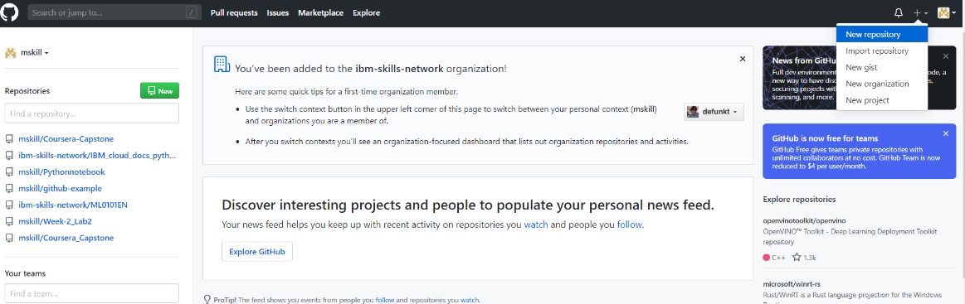

1. Provide the necessary details like repository name. Select repository as Public and initialize the READMD. Click ‘Create’

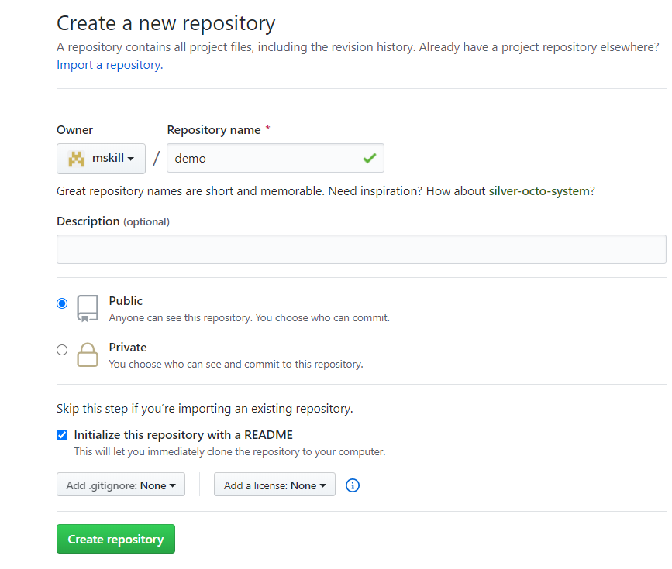

1. Now, your repository is created, and it looks as:

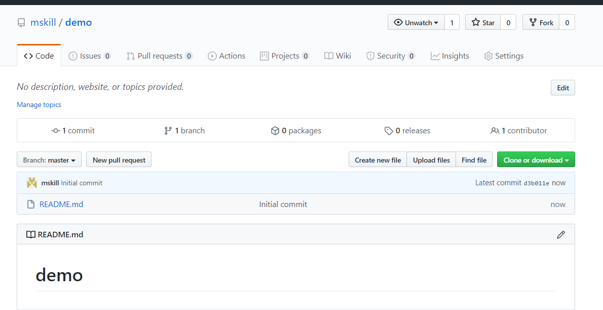

1. To download the repository, we have option ‘Clone and download’. Also, there are two options to copy repository locally using ‘SSH’ and ‘HTTPS’

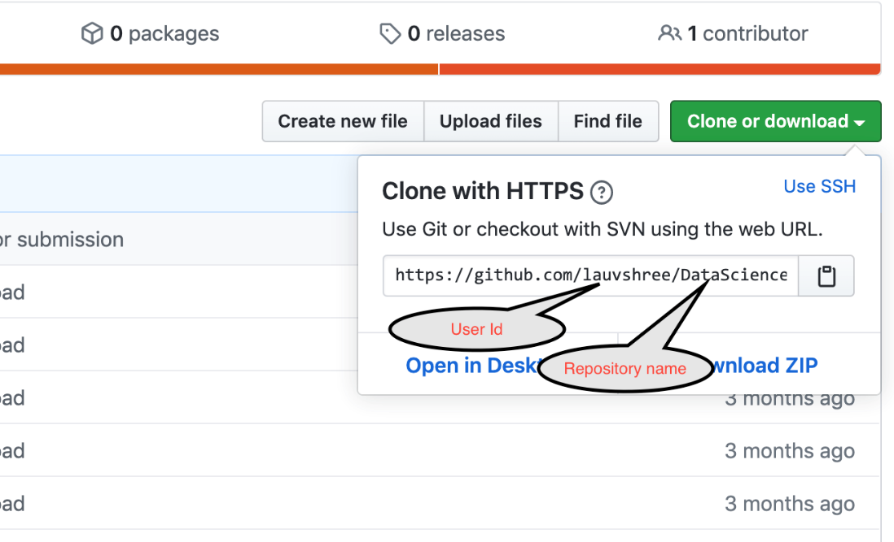

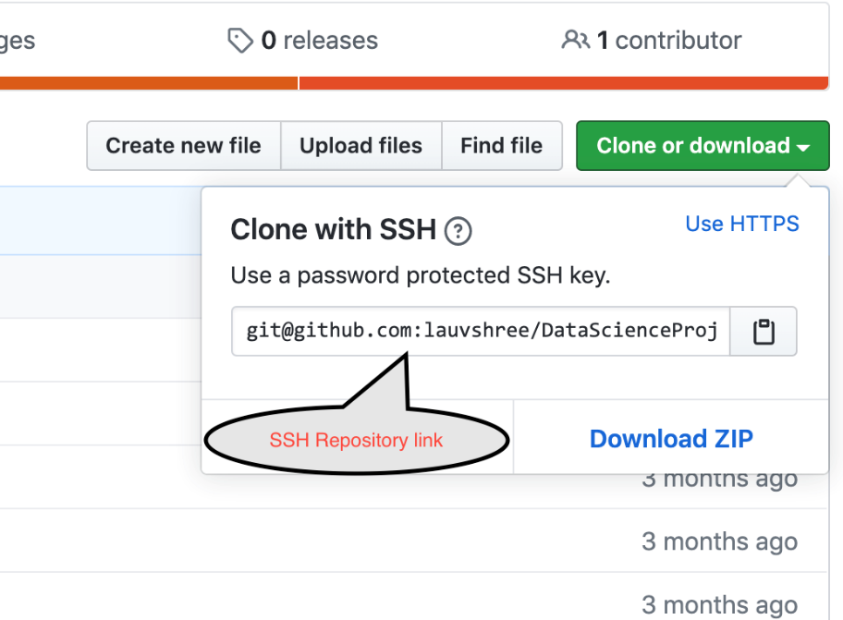

1. Copy the SSHRepositoryLink on to your clipboard.
2. These instructions presume that you have SSH key generated. However, if you don't have one please follow the step-by-step procedure in this [link](https://help.github.com/en/enterprise/2.15/user/articles/generating-a-new-ssh-key-and-adding-it-to-the-ssh-agent) before you proceed further.
3. Open the command prompt or terminal to use the GitHub commands:

To change the directory simply use:

cd <name of the directory you want to change to>

To go to the folder **“Downloads”** use: cdDownloads

Create a empty folder in Downloads using SSH repository link that we have created in GitHub Repository as:

git clone pastesshrepositorylinkhere

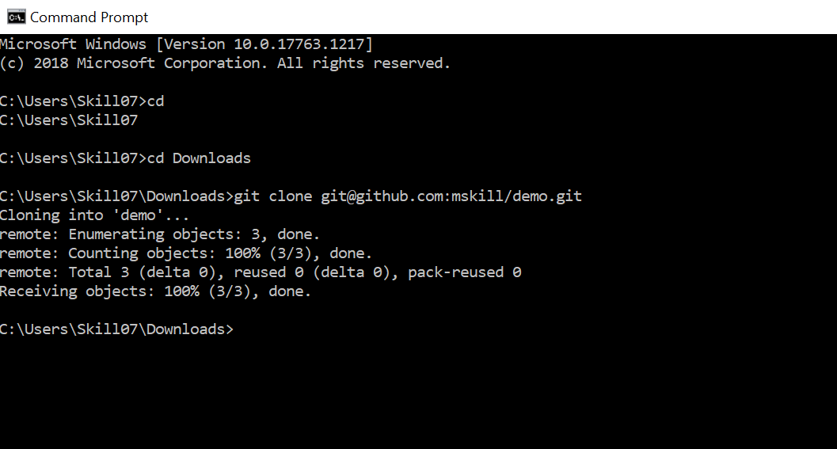

Now, the folder is copied to my ‘Downloads’. Just check the ‘Downloads’ have you got the folder demo?

1. To check my folder, enter the folder using cd command again as:

cd demo

1. Get the list of the files in the folder demo, use:

**For Windows**: dir

**For Mac**: *ls*

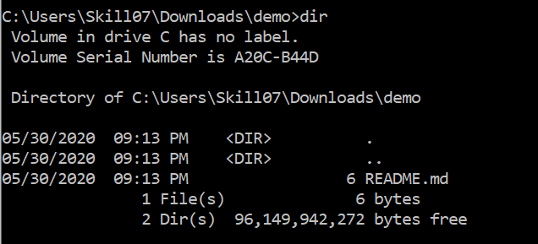

1. To view the content of the file:

**For Windows:** typeREADME.md

**For Mac**: cat README.md



1. To open a README.md file:

**For Windows:** notepad README.md

**For Mac:** open README.md

1. To create a new file:

**For Windows**: notepad test.txt

**For Mac**: vi test.txt

1. Add to the repository:

**For Windows/Mac:** git add test.txt

Check the status of the file using:

git status

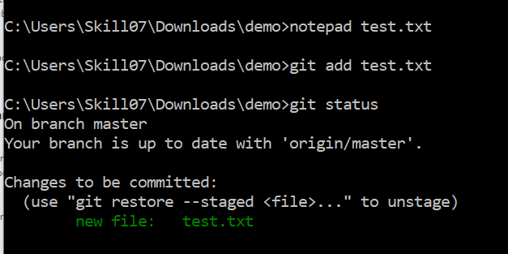

Similarly, add the new file as shown below:

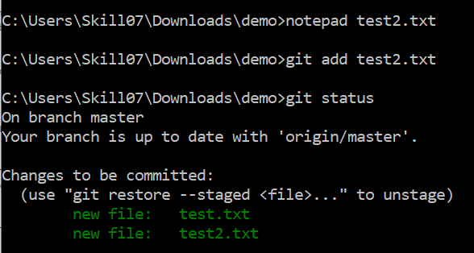

Commit the changes in the repository using:

git commit -m “write message here”

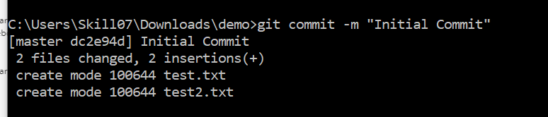

Push the file to remote repository using:

git push

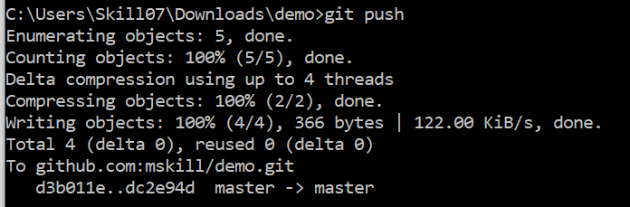

**Now, this make the changes in my GitHub repository**

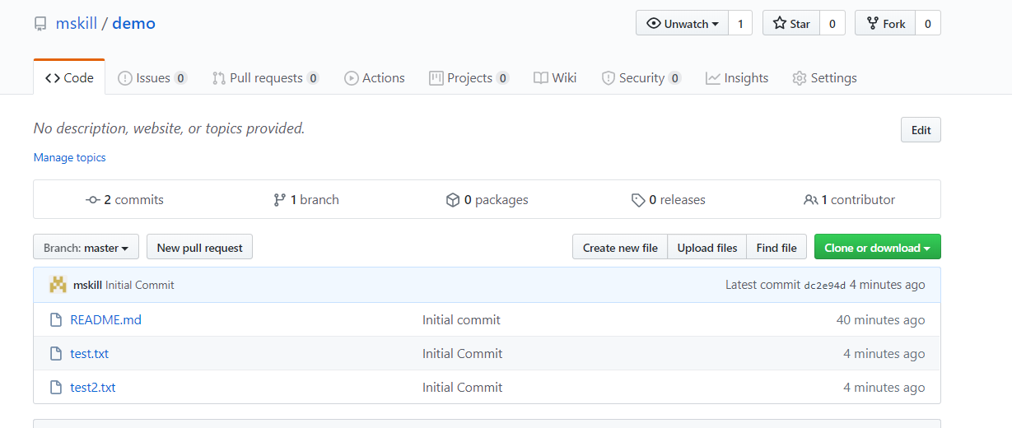

**Create a repository now without README.md file**

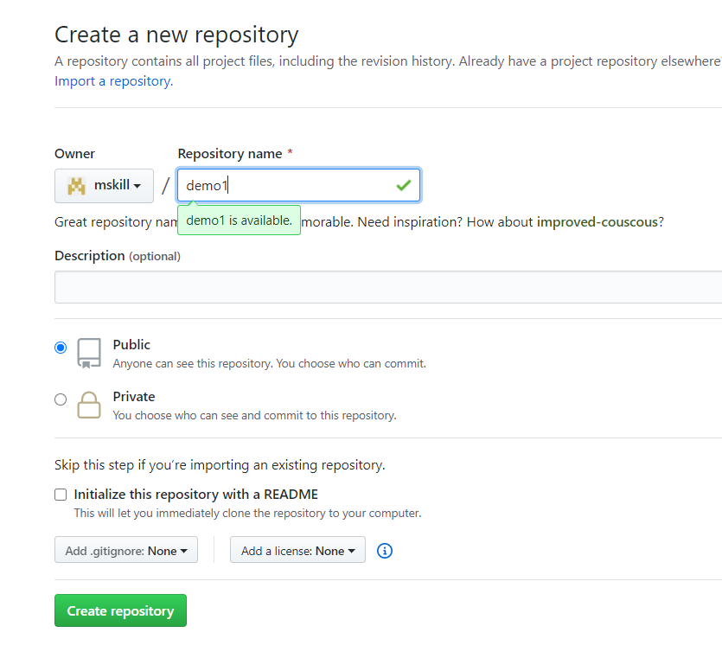

Copy the SSHRepositoryLink on to your clipboard just as in Step 6.

**To come out from the demo folder first use**

**c**d ..

To make a directory in download folder:

mkdir demo1

cd demo1

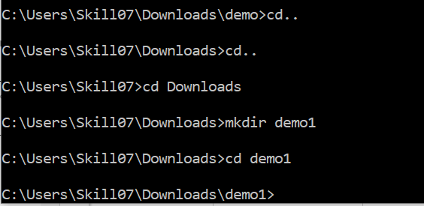

To create a readmd file use

echo "# demo1" >> README.md

Initialize the directory

git init

Create and add a README.md file. You can use a normal text editor depending on which OS you are using.

git add README.md

Check the status of the file

git status

Commit the changes

git commit -m "first commit"

Add the origin where we have to push the file. This is the SSHRepositoryLink you copied when you created the repository.

git remote add origin git@github.com:mskill/demo1.git

Push the file

git push -u origin master

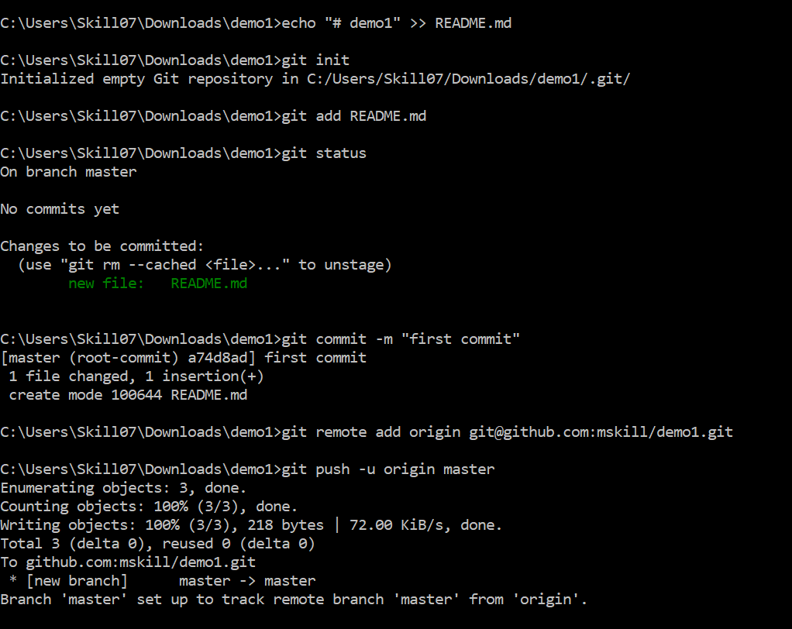

Now, the README.md file is created in our repository

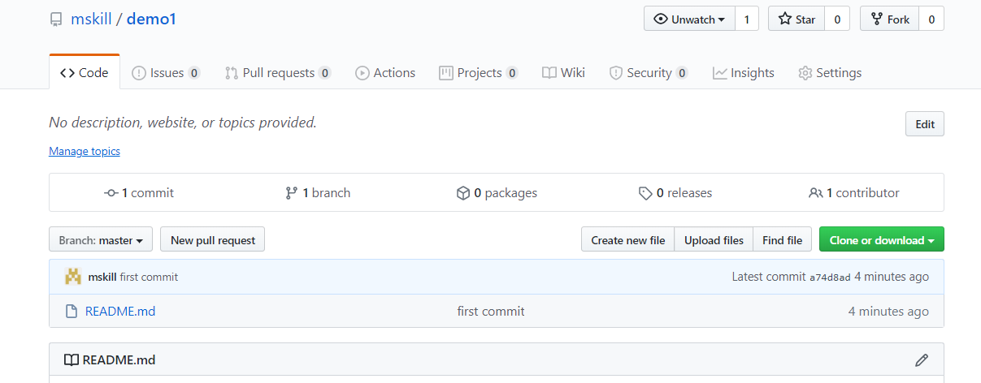

**GITHUB – PART 2**

**Creating a file in Remote repository**

Provide the file name and add a description to that file. To commit the changes in the repository, click ‘Commit New File’

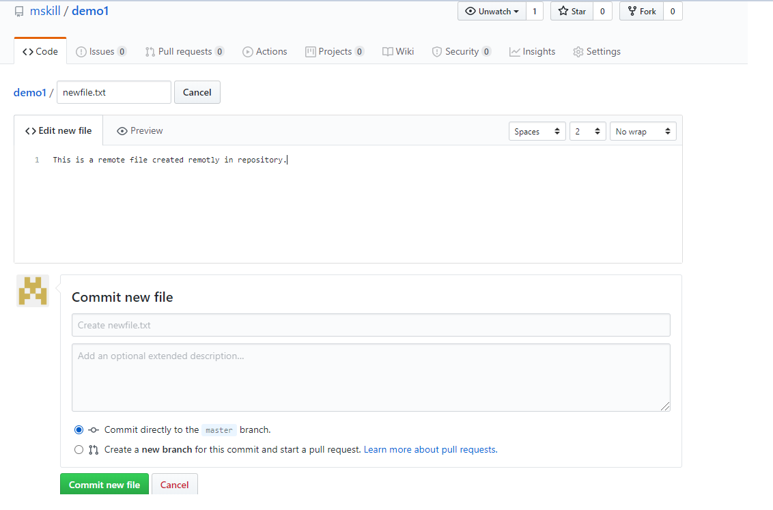

Adding a file remotely will not be there in the local directory. Check the files using dir

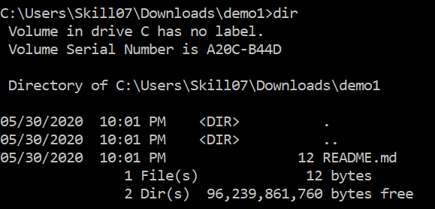

As per the screenshot above, there is 1 file in the repository.

To pull the file that is added in remote repository to local repository, we use PULL command

git pull

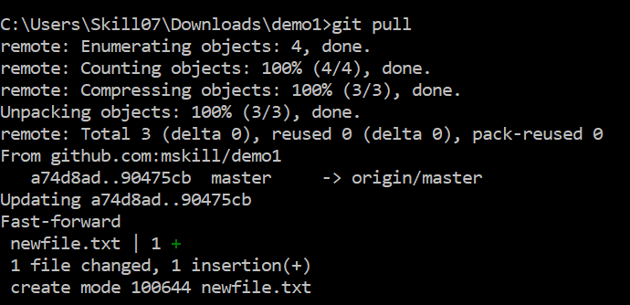

After pull, if I check the local repository using dir, there are 2 files as shown:

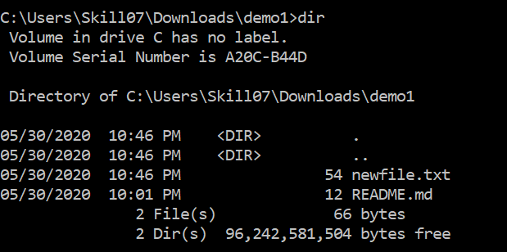

To add a branch in master branch

git branch branchname

Switch the branch

git checkout branchname

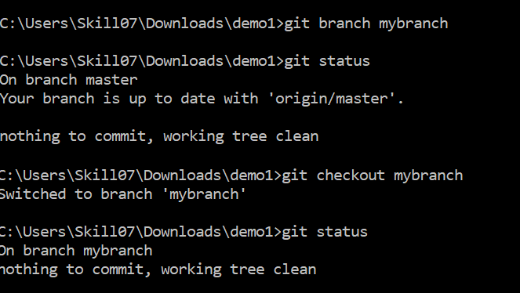

Adding a file in branch

echo "#content">> filename.txt

Then add the file and push the file. To create the branch remotely we have to use

git push --set-upstream origin branchname

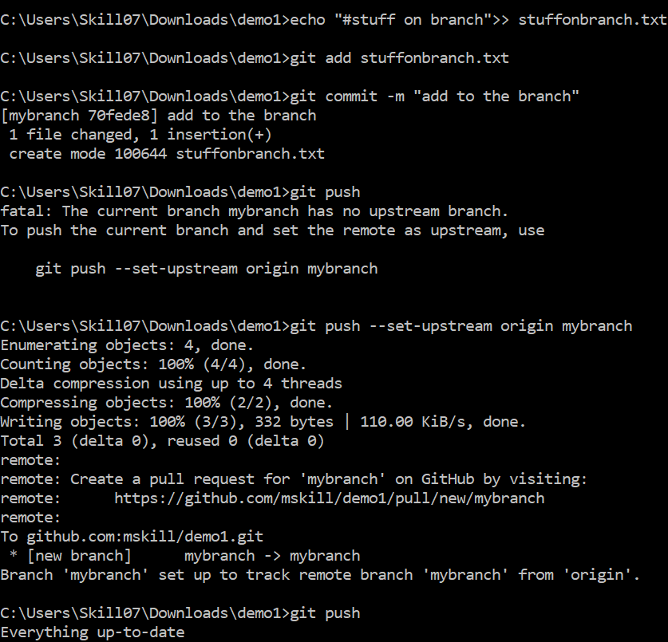

Switch the branch again to the master using

git checkout master

Merge command to merge the branches

git merge mybranch

As the merge command is used the new create branch will be merged to the master branch and the file will be inserted to it. Previously, we have 2 file in the master, now there are 3 files. Make sure to push the files using git push

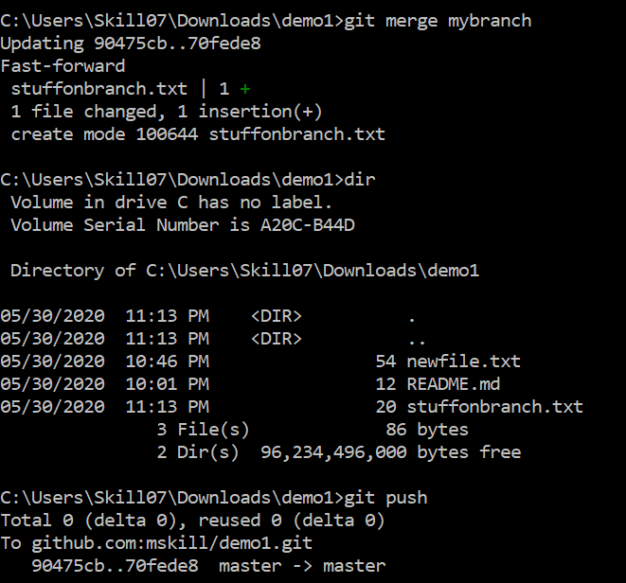

Now, the file which is in the branch, is now in the master branch

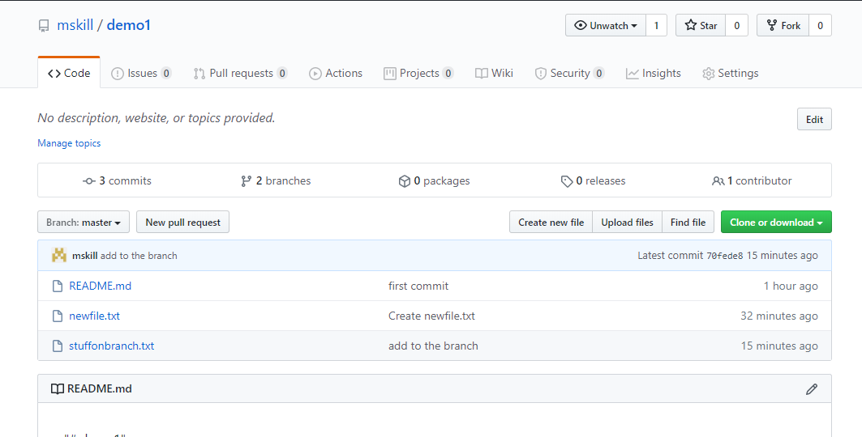

**GITHUB – PART 3**

**How to fork a repository and commit the fork repository and create a pull request.**

Open the link:  <https://github.com/romeokienzler/TensorFlow/>

Click ‘Fork’ and copy the repository in your account.

Copy the SSH Repository Link and clone it locally using:

git clone yoursshrepolink

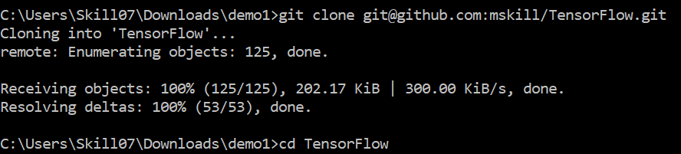

Open and edit any file in the editor.

After saving the file,

git add .

And commit the changes with the message:

git commit -m “message”

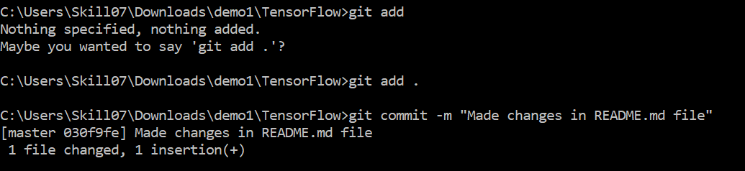

git push to make the changes in remote repository

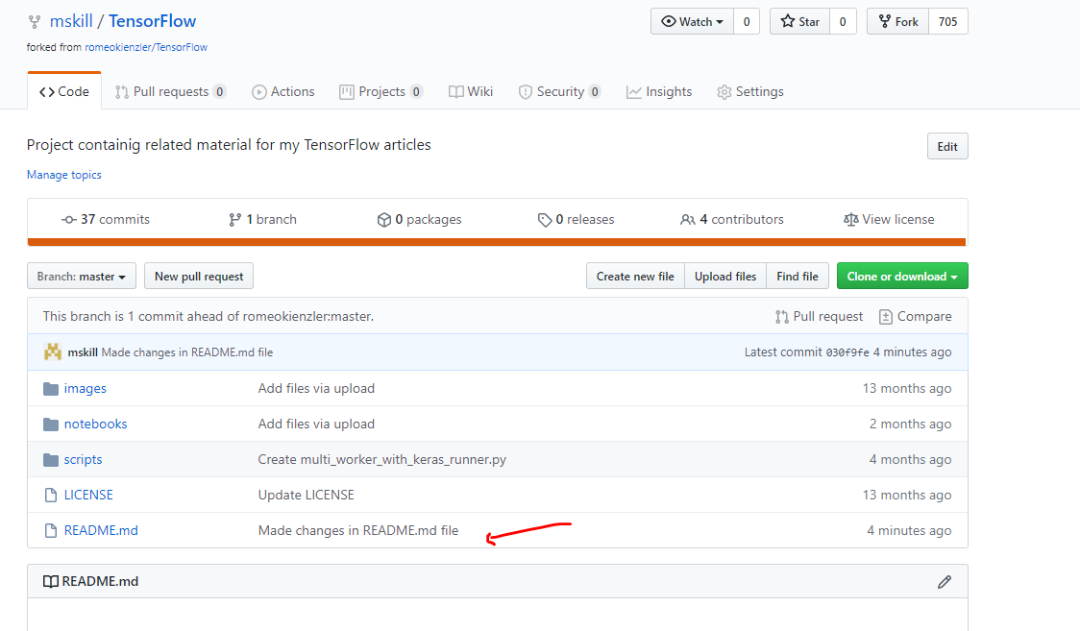

Click ‘Compare’ to compare the changes.

**NOTE: This request will go to AUTHOR of the repository and if the changes looks good, only then the original repository can get the changes.**

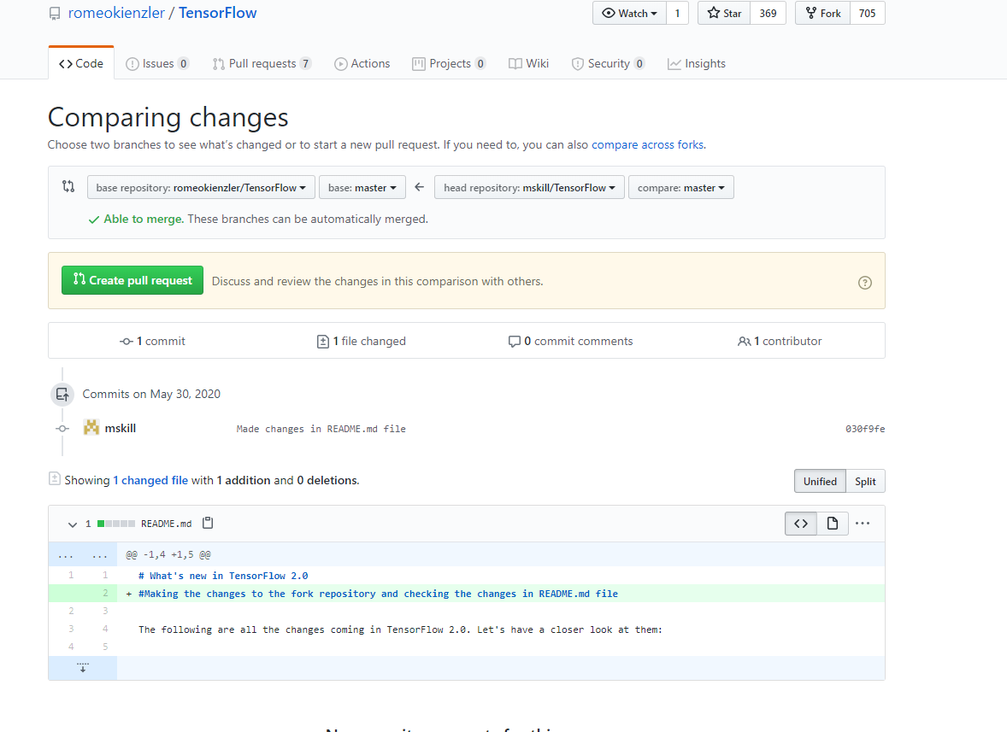

Create a Pull request to make the changes in the original file.